Folder Structures of Automation Testing Scripts

This document will introduce the folder structures for the automation testing scripts for SourceOne.

All our automation testing scripts will be managed on the ClearCase and following the folder structures defined in this document. Our Galaxy framework follows this definition to get the scripts.

Below is the folder structure:

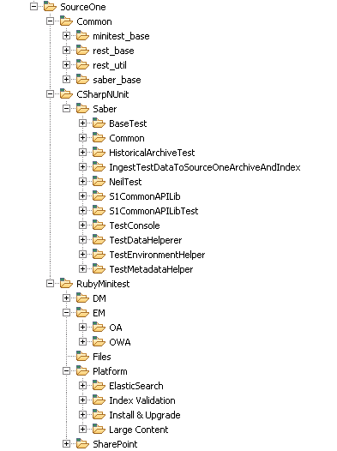

Three root folders:

* Common: Contains the modules that will be used by both the C# and Ruby tests or other common utilities
* CSharpNUnit: Contains the test scripts for the C# NUnit automation testing scripts.
* RubyMinitest: Contains all the test scripts for the Ruby Minitest automation scripts. The subfolders are organized by the Module->Feature defined in the RQM.